**\*\*\*\*\*\*\*\*\*\*\*\*\*\*\*\*\*\*\*\*\*\*\*\*\*\*\*\*\*\*\*\*\*\*\*\*\*\*\*\*\*\*\*\*\*\*\*\*\*\*\*\*\*\*\*\*\*\*\*\*\*\*\*\*\*\*\*\*\*\*\*\*\*\*\*\*\*\***

**Date:26.02.21 Create Web page Meera.R**

**EX.NO.:1a 311118104039**

**\*\*\*\*\*\*\*\*\*\*\*\*\*\*\*\*\*\*\*\*\*\*\*\*\*\*\*\*\*\*\*\*\*\*\*\*\*\*\*\*\*\*\*\*\*\*\*\*\*\*\*\*\*\*\*\*\*\*\*\*\*\*\*\*\*\*\*\*\*\*\*\*\*\*\*\*\*\***

**To create a website using HTML and embed a map.**

<!-- HTML code for embedding a map and indicating hotspots and their information-->

<!--DOCTYPE html-->

<!--Main.html-->

<html>

<head>

<h1> INDIA </h1>

<img src="C:\Users\Meera Ramanathan\Desktop\6th Sem\IP lab\india-map.jpg" usemap="#india" alt="India map">

</head>

<body>

<map name="india"> <!--Specify coordinates of hotspots to show description-->

<area shape="circle" coords="336,723,30" target="blank" href="chennai.html">

<area shape="circle" coords="256,257,30" target="blank" href="delhi.html">

<area shape="circle" coords="287,599,30" target="blank"href="hyderabad.html">

<area shape="circle" coords="287,599,30" target="blank" href="mumbai.html">

</map>

</body>

</html>

<!--Chennai.html-->

<html>

<head>

<h1><center>CHENNAI</h1>

</head>

<body>

<p>

<ul> <!--Use lists to display information about Chennai-->

<li>Chennai is the capital of tamilnadu.</li>

<li>It is one of the cities in the golden quadrilateral.</li>

<li>It is famous for beaches.</li>

<li>It was formerly known as Madras.</li>

</p>

</body>

</html>

<!--Hyderabad.html-->

<html>

<head>

<h1><center>HYDERABAD</h1>

</head>

<body>

<p>

<ul>

<li>Hyderabad is the capital of telangana.</li>

<li>charminar is famous in hyderabad.</li>

<li>Variety of spicey foods are famous here.</li>

</ul>

</p>

</body>

</html>

<!--Mumbai.html-->

<html>

<head>

<h1><center>MUMBAI</h1>

</head>

<body>

<p>

<ul> <!--Specify information about mumbai using list-->

<li>Mumbai is the city of Bollywood.</li>

<li>It was earlier called as bombay.</li>

<li>It has one of the biggest airports.</li>

</ul>

</p>

</body>

</html>

**OUTPUT SNAPSHOTS:**

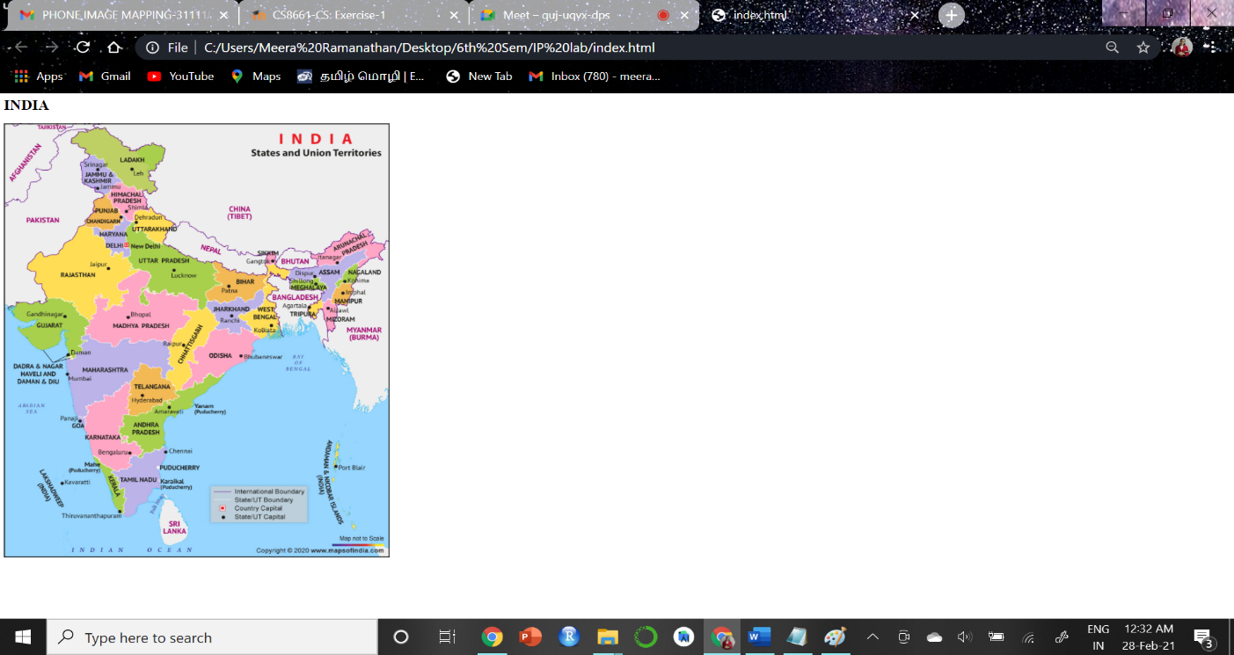

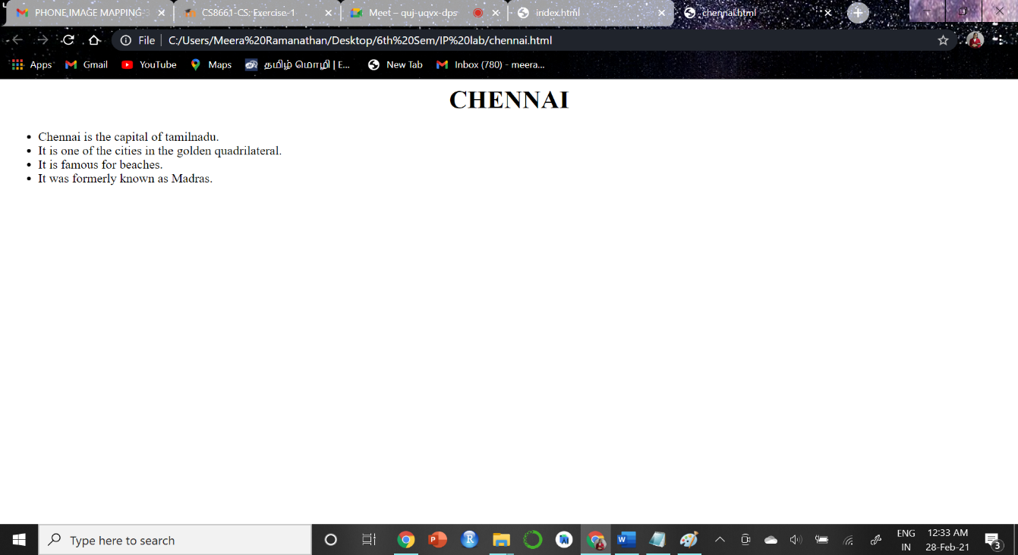

2.

<!-- HTML code for durcting to a food website when clicking on a certain region of the picture-->

<!--DOCTYPE html-->

<!--Main.html-->

<html>

<head>

<h1> North Indian Thali </h1>

<img src="C:\Users\Meera Ramanathan\Desktop\6th Sem\IP lab\food.jpg" target="blanl" usemap="#food" alt="North Indian Thali">

</head>

<body>

<map name="food"> <!--Linking the picture to the map-->

<!-- speicifying coordinates to get information-->

<area shape="rect" coords="64,352,181,535" target="blank" href="https://www.zomato.com/akola/restaurants?dishv2_id=edb7c6cd49d0757e98030eeaecb9d5ca_2&category=1">

<area shape="rect" coords="212,393,383,570" target="blank" href="https://www.zomato.com/akola/restaurants?dishv2_id=3767b450824877f2b8f284f7a5625440_2&category=1">

<area shape="rect" coords="225,165,329,257" target="blank" href="https://www.zomato.com/akola/restaurants?dishv2_id=a31d0324d8e3f76a6de5516ebbd5be0c_2&category=1">

</map>

</body>

</html>

**OUTPUT SNAPSHOTS**

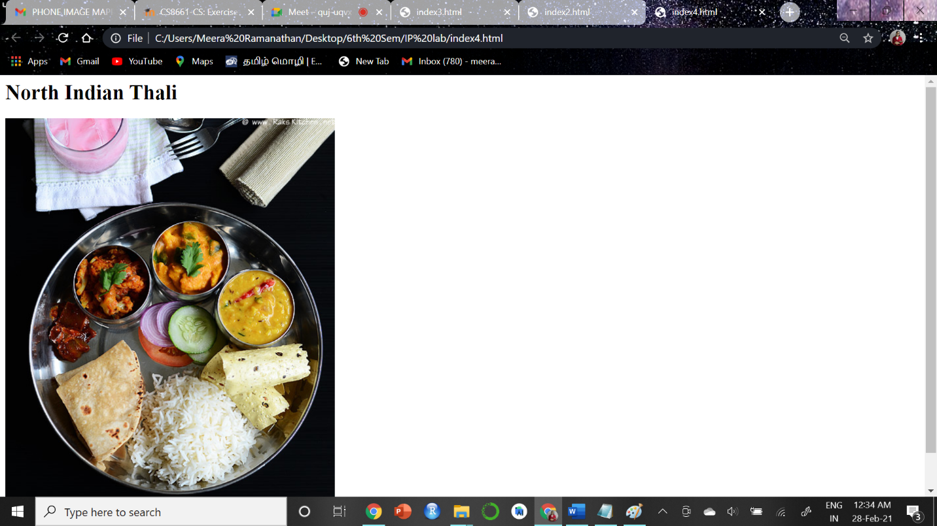

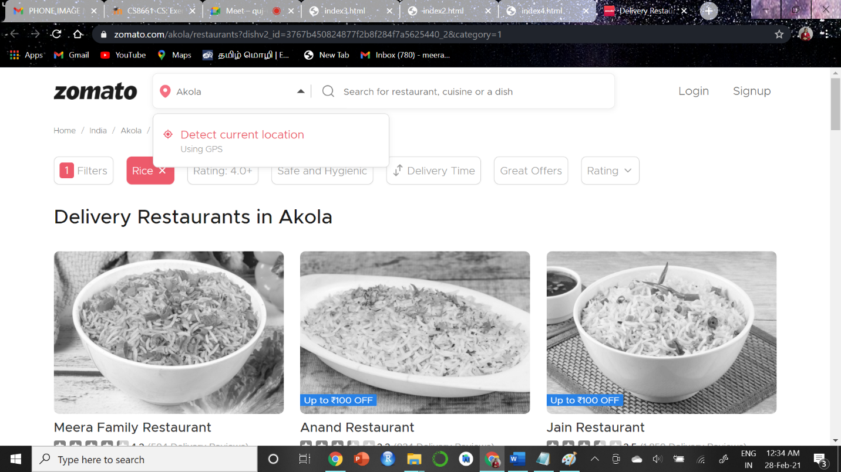

3.

<!-- HTML code for dircting to a amazon website when clicking on a certain region of the picture to see the product-->

<!--DOCTYPE html-->

<!--Main.html-->

<html>

<head>

<h1> Home Decor </h1>

<img src="C:\Users\Meera Ramanathan\Desktop\6th Sem\IP lab\home decor.jpeg" target="blank" usemap="#decor" alt="Home Decor">

</head>

<body>

<map name="decor"> <!--Linking the picture to the map-->

<!-- speicifying coordinates to get information-->

<area shape="rect" coords="572,457,633,569" target="blank" href="https://www.amazon.com/s?k=pillow&ref=nb_sb_noss_1">

<area shape="rect" coords="11,305,179,608" target="blank" href="https://www.amazon.com/s?k=plant&ref=nb_sb_noss_1">

<area shape="rect" coords="405,259,627,406" target="blank" href="https://www.amazon.com/s?k=potraits+wall+decor&crid=2PX6XR34ZPPYS&sprefix=potraits%2Caps%2C362&ref=nb_sb_ss_ts-doa-p_1_8">

</map>

</body>

</html>

**OUTPUT SNAPSHOTS:**

